



**Creo Direct Embedded Client Installation Guide**

PLM-S

Damstraat 70 - B 9220 Hamme (VL), BE 0684.702.709

www.plm-s.com

**User Guide - V 5.4**

**CDEC installation**

***Important Note:***

***During the installation of CDEC please make sure that the Creo Direct session is closed***

***This CDEC installation package is only for the English version of Creo Elements Direct 19.0***

***The “uninstallCDEC.bat” has to be only Run as Administrator.***

***The “Deploy.bat” has to be only Run as Administrator.***

***If the CDEC is going to be installed for the first time(i.e. CDEC is not already present/installed) on that particular PC then the User must follow*** ***Section 1******. If the CDEC is already installed on the PC and the User wants to reinstall it again then follow*** ***Section 2***

**CDEC_Installation_Package**

**CDEC_English_CreoDirect19.0.zip** file is placed in this Onedrive link [CDEC_Package_share](https://itsnetbrugge-my.sharepoint.com/:f:/g/personal/arun_3de_ae/Et8o8SjwhZNOgDXe8VgMX_oBEg7PO5FDNzhpuXz10TTkIw?e=vSjBEq)

**Section 1**

**Steps for first time CDEC installation for Creo Elements Direct Elements 19.0**

This section is only for installing CDEC in a new environment. If the machine has already CDEC installed in it and you want to reinstall it again then ignore Section 1 and please follow Section 2

1. Copy the **CDEC_English_CreoDirect19.0.zip** file and paste it into the location of the machine where the installation has to be done. Unzip the file.



1. You will find the below files inside the **CDEC_English_CreoDirect19.0** folder

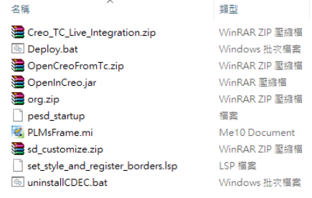

1. Inside the **CDEC_English_CreoDirect19.0** folder, a Windows Batch file named “Deploy.bat” will be present

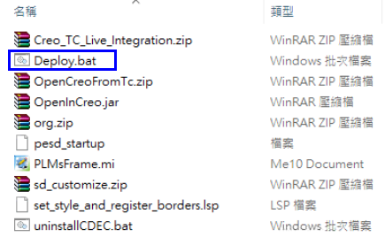

1. Open the Deploy.bat file in any text editor preferably **Notepad++**

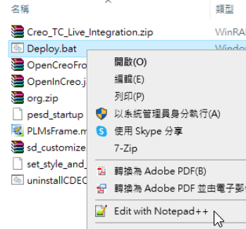

1. Setting the **TC_ROOT** path in Deploy.bat

In the **CDEC_English_CreoDirect19.0** folder. Open **Deploy.bat** file using any text editor preferably Notepad++ and check the **TC_ROOT** path is the same as in the client machine where the CDEC has to be installed as shown in the below image. If the **TC_ROOT** path is not correct then change the path, **Save** the file and close it

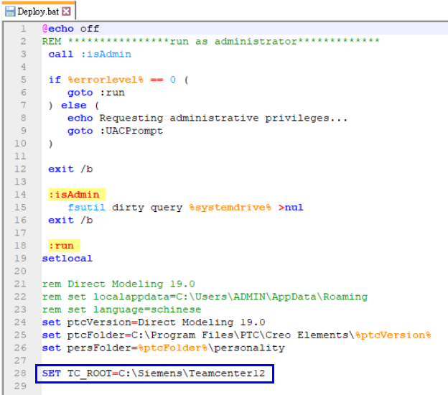

1. Then Right-click on **Deploy.bat** and select **Run as administrator** to start the installation. A command window showing the status of the installation will be displayed. The Deploy.bat has to be only **Run as administrator**

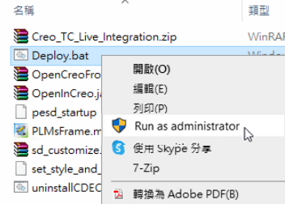

1. A successful installation is to not get any errors on the command prompt window After the installation is complete, press any key to close the below command window.

*A reference image of a successful installation of CDEC where the command prompt is without any errors is shown below*

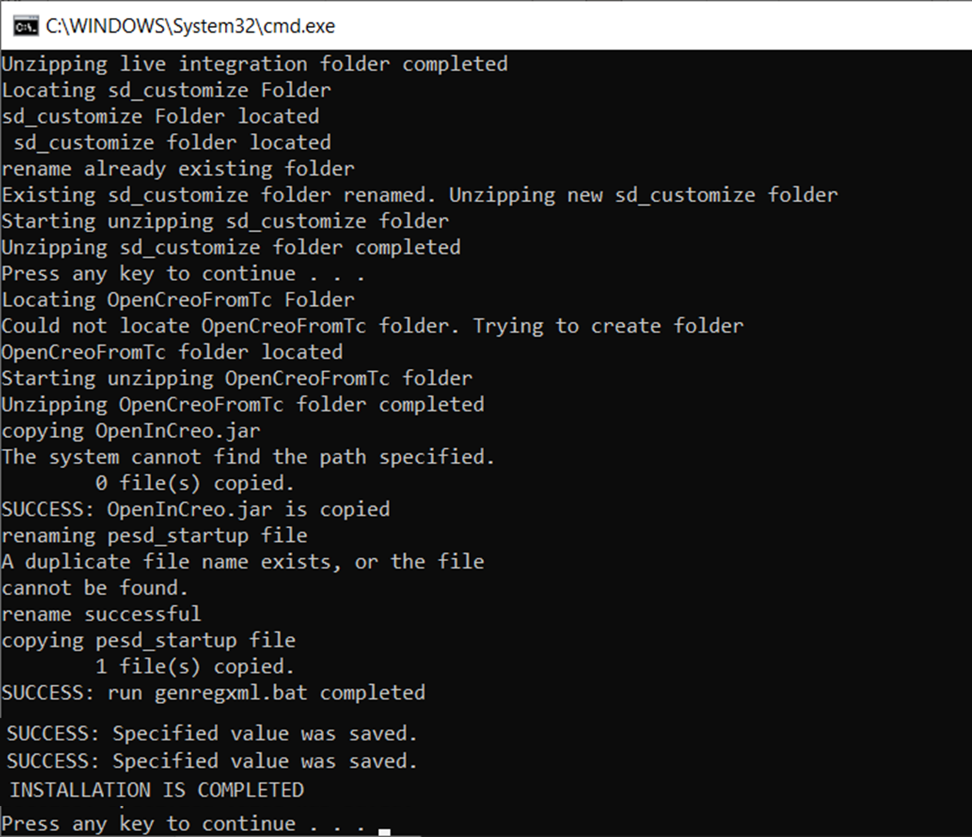

*A reference image of a successful installation of CDEC where the command prompt is without any errors is shown below*

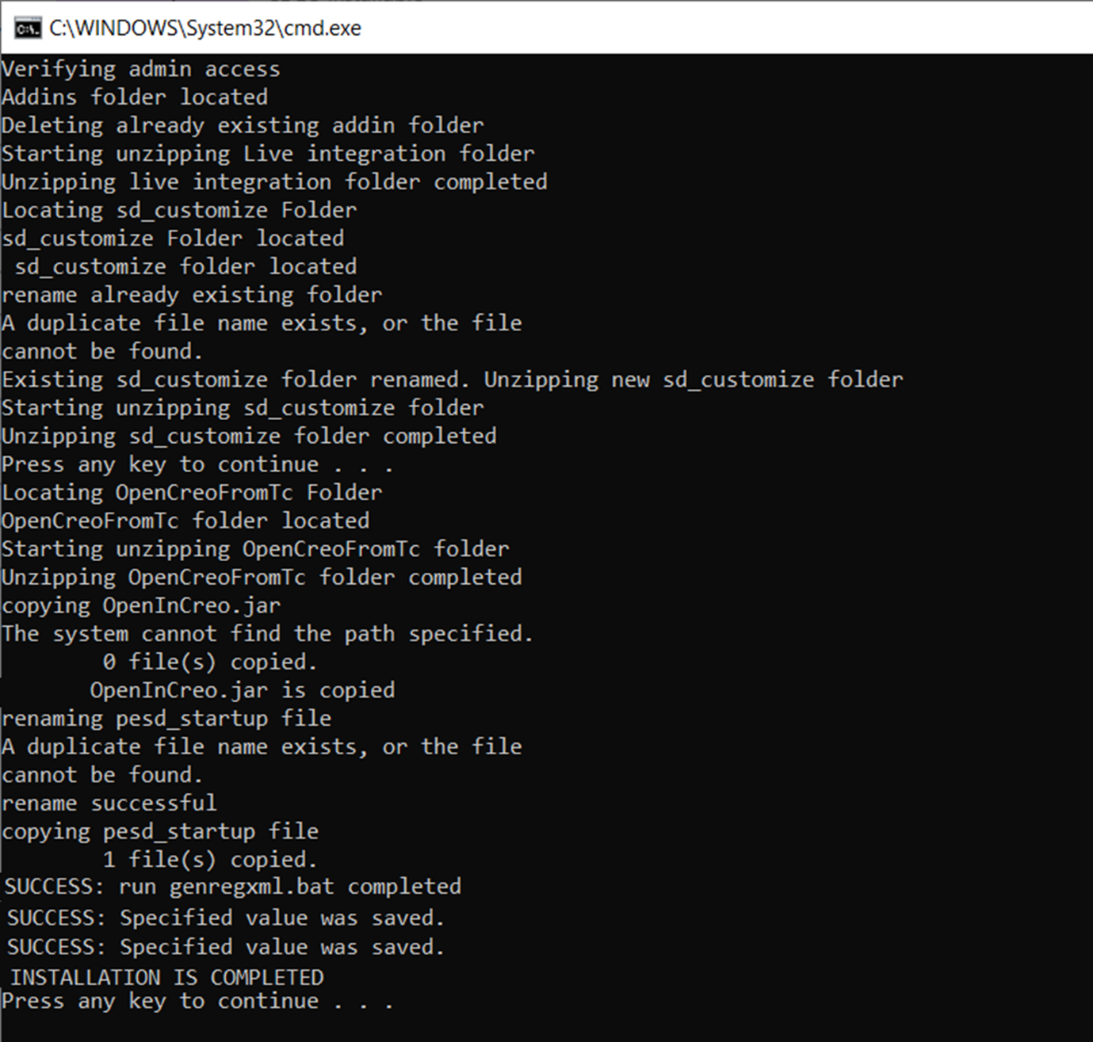

1. The unsuccessful installation will be having shown an **error** in the command window

Example of images showing error in command prompt window

*Reference image 1*

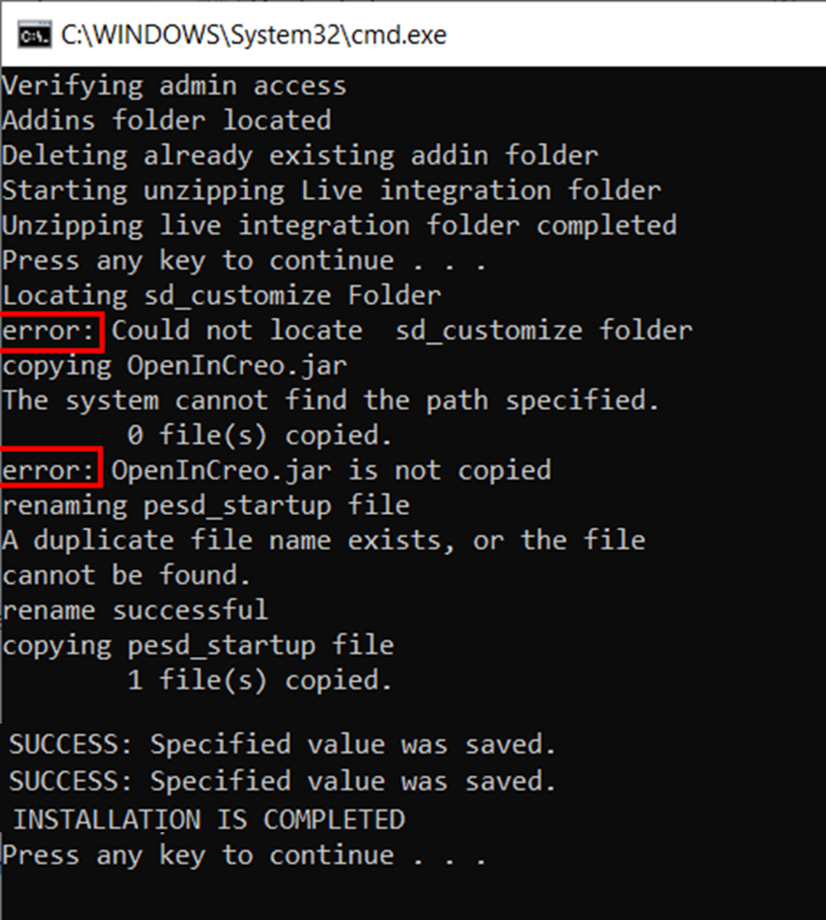

*Reference image 2*

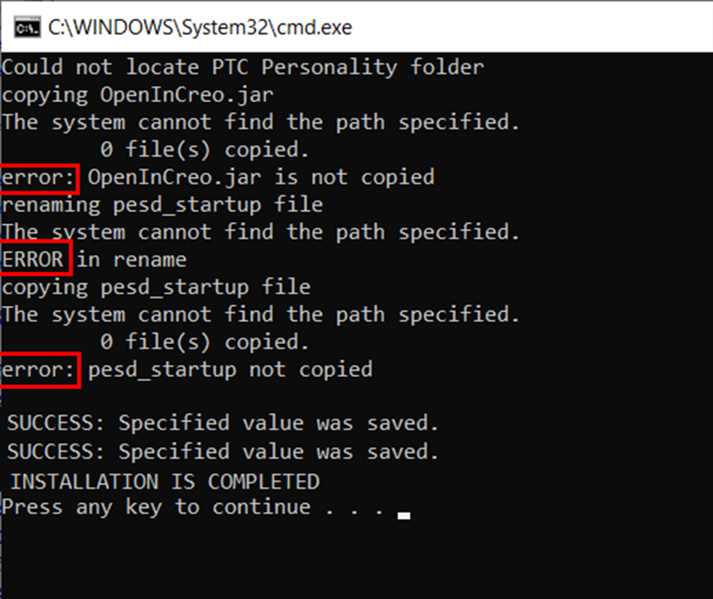

1. During the installation process if a dialog pops up asking to Replace or skip these files please click **Replace the files in the destination** option as shown in the below image

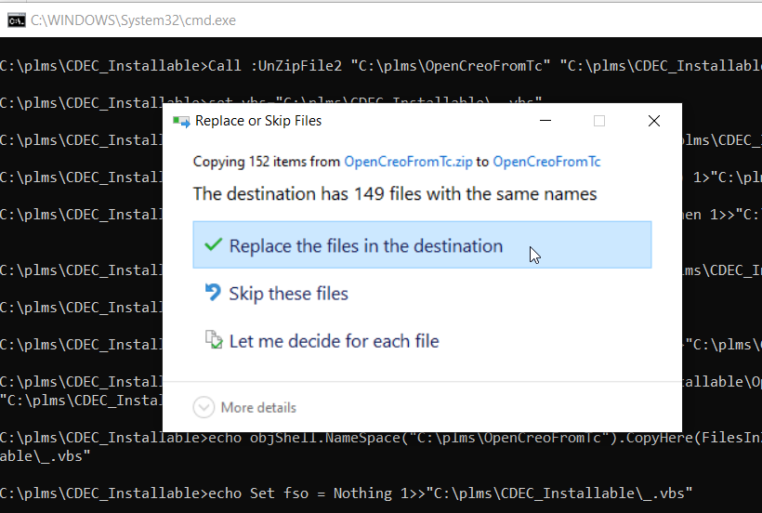

1. Upon successful installation, the Teamcenter tab will appear in Creo Direct Modelling 19.0 as shown in the below image

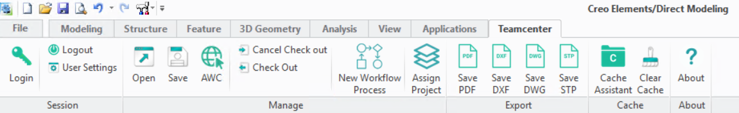

**Section 2**

**Steps for the reinstallation of CDEC installation for Creo Elements Direct Elements 19.0**

This section is only for reinstalling CDEC in a PC that is If the machine has already CDEC installed in it and you want to reinstall it again then please follow this Section 2

1. Copy the **CDEC_English_CreoDirect19.0.zip** file and paste it into the location of the machine where the installation has to be done. Unzip the file.



1. You will find the below files inside the **CDEC_English_CreoDirect19.0** folder



1. Open the folder in the machine where the CDEC has to be installed. Inside the **CDEC_English_CreoDirect19.0** folder, a Windows Batch file named “uninstallCDEC.bat” will be present

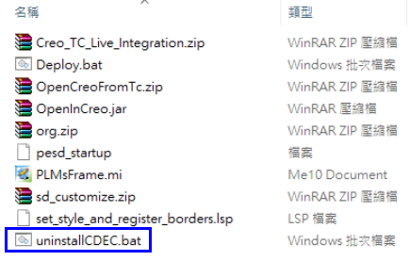

1. Open the “uninstallCDEC.bat” file in any text editor preferably **Notepad++**

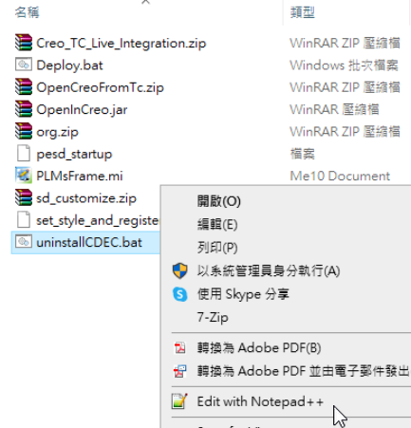

1. Setting the **TC_ROOT** path in uninstallCDEC.bat

In the **CDEC_English_CreoDirect19.0** folder. Open **uninstallCDEC.bat** file using any text editor preferably Notepad++ and in line number **28** check the **TC_ROOT** path is the same as in the client machine where the CDEC has to be installed as shown in the below image. If the **TC_ROOT** path is not correct then change the path, **Save** the file and close it

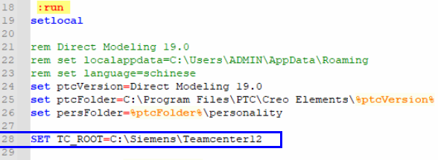

1. This is a very important step if the user tries to install CDEC in a PC where is already present. So the user has to uninstall first by performing this step to uninstall already present CDEC, Right-click on **uninstallCDEC.bat** and select **Run as administrator** to start the uninstallation of already installed CDEC. A command window showing the status of the installation will be displayed. The Deploy.bat has to be only **Run as administrator**

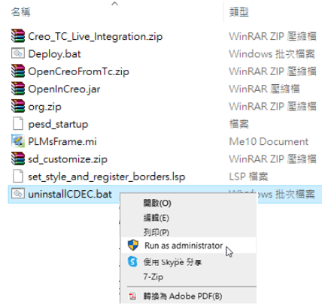

1. Inside the **CDEC_English_CreoDirect19.0** folder, a Windows Batch file named “Deploy.bat” will be present



1. Open the Deploy.bat file in any text editor preferably **Notepad++**



1. Setting the **TC_ROOT** path in Deploy.bat

In the **CDEC_English_CreoDirect19.0** folder. Open **Deploy.bat** file using any text editor preferably Notepad++ and check the **TC_ROOT** path is the same as in the client machine where the CDEC has to be installed as shown in the below image. If the **TC_ROOT** path is not correct then change the path, **Save** the file and close it



1. This step must be performed only after uninstalling already present CDEC in the PC (follow point 6 to uninstall CDEC)Then Right-click on **Deploy.bat** and select **Run as administrator** to start the installation. A command window showing the status of the installation will be displayed. The Deploy.bat has to be only **Run as administrator**

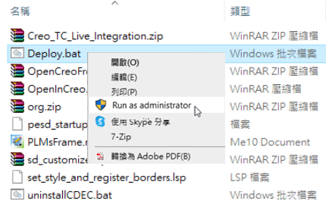

1. A successful installation is to not get any errors on the command prompt window After the installation is complete, press any key to close the below command window.

*A reference image of a successful installation of CDEC where the command prompt is without any errors is shown below*



*A reference image of a successful installation of CDEC where the command prompt is without any errors is shown below*



1. The unsuccessful installation will be having shown an **error** in the command window

Example of images showing error in command prompt window

*Reference image 1*



*Reference image 2*



1. During the installation process if a dialog pops up asking to Replace or skip these files please click **Replace the files in the destination** option as shown in the below image



1. Upon successful installation, the Teamcenter tab will appear in Creo Direct Modelling 19.0 as shown in the below image



Issues

Some times can experience the below .NET issue when the user tries to launch Creo after CDEC installation

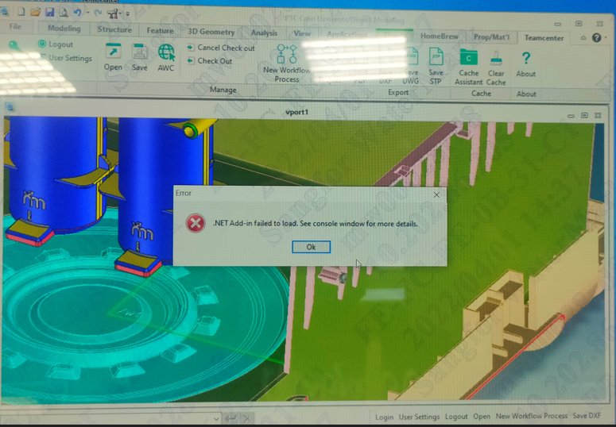

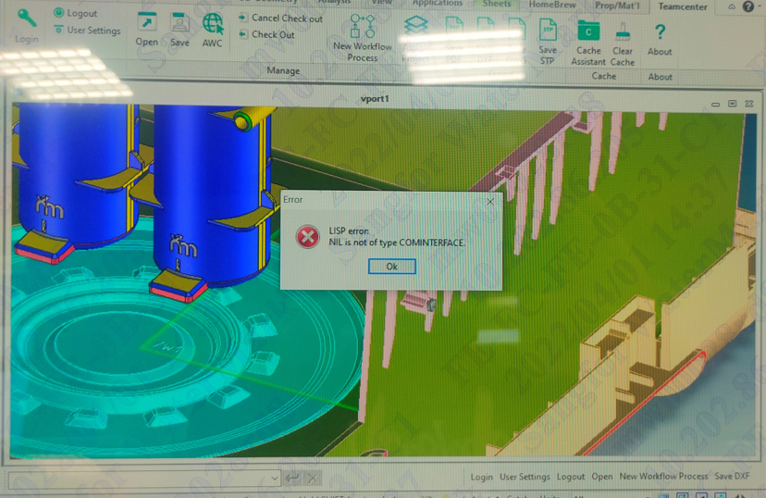

This issue is because the dll files gets blocked after copying but now I have fixed this issue in the installation script

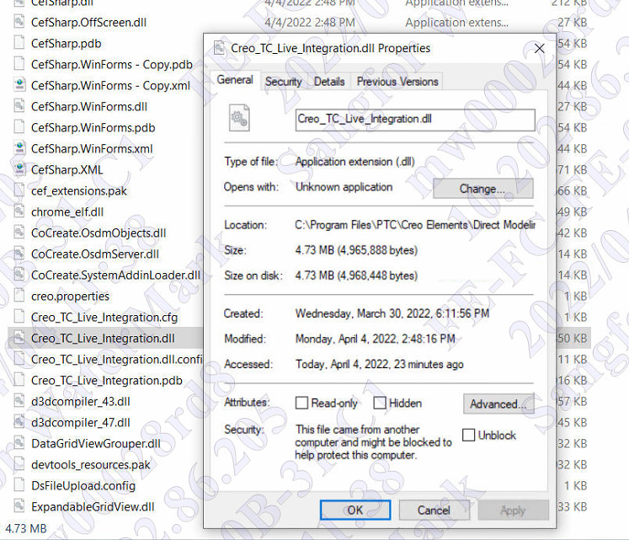

Document History

|  |  |  |  |
| --- | --- | --- | --- |
| Revision | Date | Author | Description |
| 5.3 | 16 Dec 2021 | Arun | Installation of CDEC |
| 5.4 | 31 Mar 2022 | Arun | Creating 2 Sections for installation of CDEC |
|  |  |  |  |